Water Supply

In a country called “Aqua”, there are two major cities, located on a Cartesian plane with coordinates {x1,y1} and {x2,y2}. There is also a river which is lying right over the x-axis. This river provides the two cities with necessary water. The two cities are above the river on the Cartesian plane, meaning, ( y1,y2 > 0 ).

Using water directly from river will be harmful for the citizen. Thus, the government of country Aqua has decided to build a water treatment facility near the river. The exact position of the facility has not been decided yet, but it has been decided that the facility will be so near to the river that it’s y-coordinate can be assumed to be 0. So for now, lets assume, the facility is located at {x3,0}.

Now, once the facility is built, water will be supplied from there to the cities using pipes. The cost of building pipes between two point is the distance between them.

So, the government wants to build the facility at such a point that the cost of building pipes from the facility to the two cities is minimum.

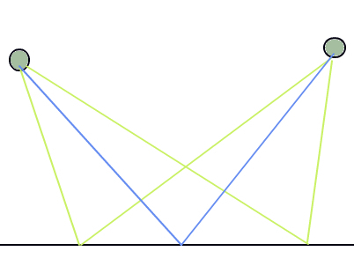

*Length of blue path is shorter than the other paths. Black line at bottom is the river.*

Given the location of the two cities, find the value of x3.

# Input:

First line will contain a single integer T (T<10000) indicating number of test case. After that, T lines will follow with four positive integers x1, y1, x2, y2 ( x1, y1, x2, y2 <= 106  ).

# Output:

For each case, print the case number, and then the value of x3 in a/b irreducible format.

Please check sample input/output to understand the format.

|  |  |
| --- | --- |
| Sample Input | Sample Output |
| 2  2 2 4 2  2 2 4 3 | Case 1: 3/1  Case 2: 14/5 |

# Limits:

|  |  |  |
| --- | --- | --- |
| Language | Time | Memory |
| C | 1 Second | 50MB |
| C++ | 1 Second | 50MB |
| Java | 4 Second | 50MB |
| C# | 4 Second | 50MB |

For Java, use main as class name, do not mark your class as public and do not use custom package. Follow Ideone rule for java compilation, if you get compile error, try your code in ideone.com to see your problem.